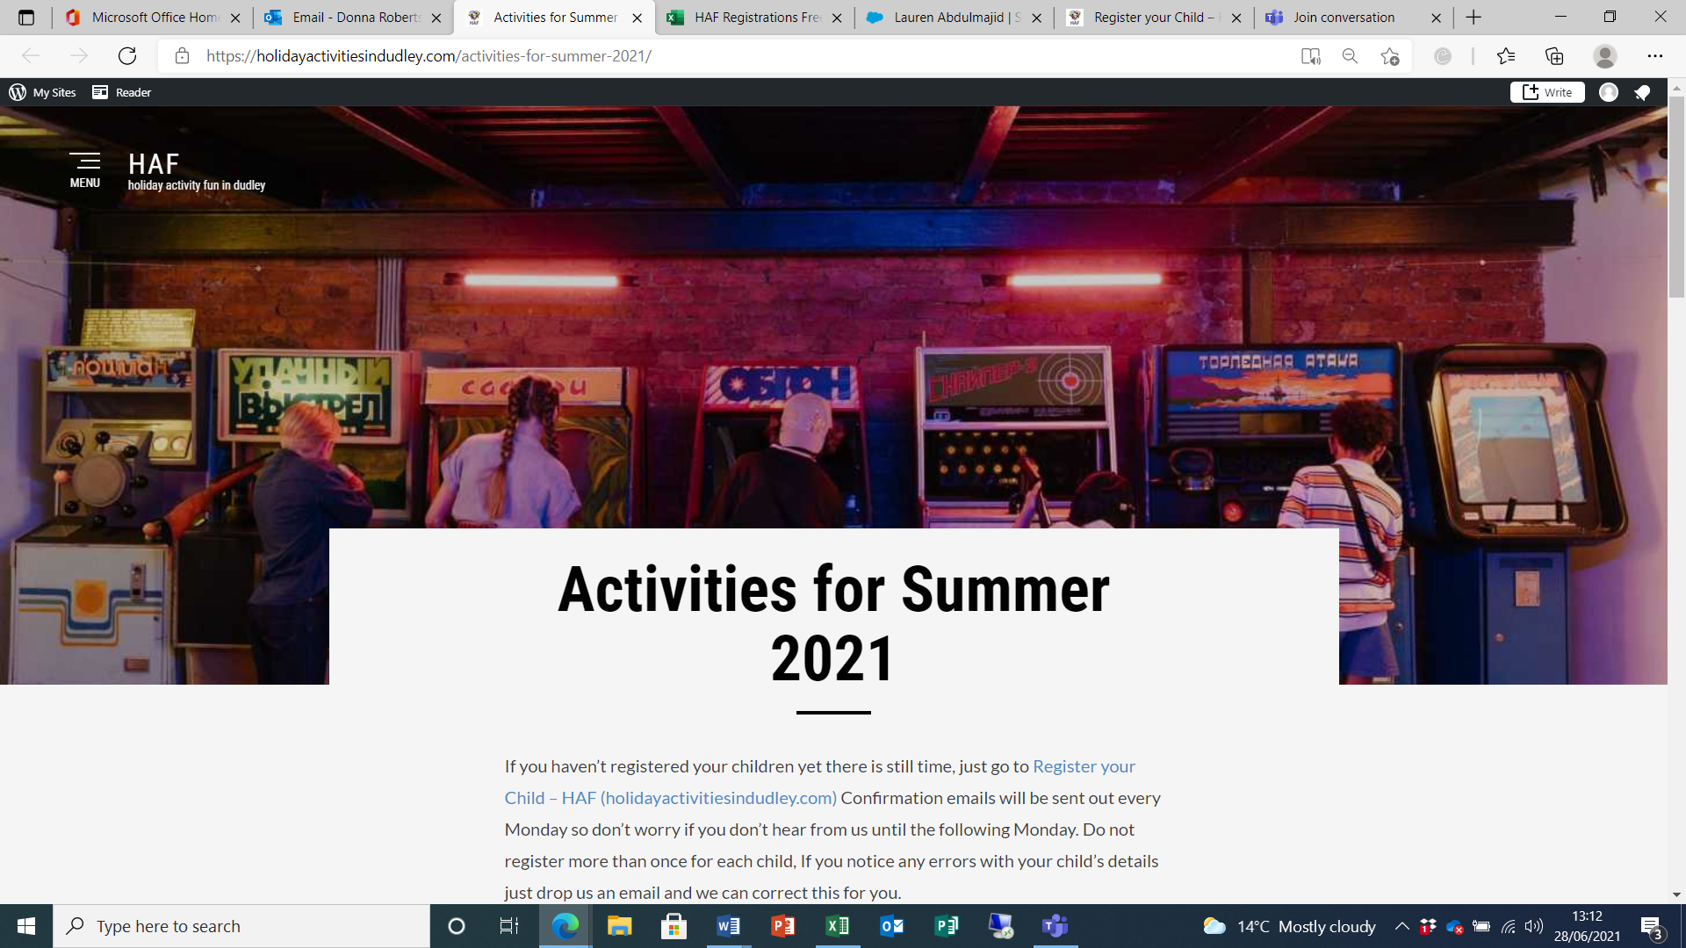

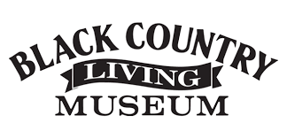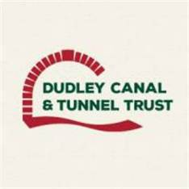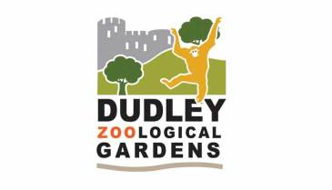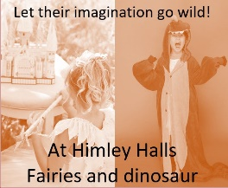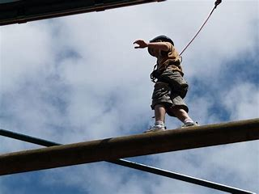

To book any of these activities you need to register via <https://holidayactivitiesindudley.com/register-your-child/> a unique reference code and link to the activities will be sent within 10 days to the email address you register with. (Please only **register once** for each child and only if you are income eligible for Free School Meals). You can then book any of the activities and more for a great summer of fun!

**Diddy Dinosaur Craft session** at Dudley Museum. Story, craft and trail all with a dinosaur theme (suitable for Reception, Year 1 & 2) Special SEND Sessions are available.

**Fancy a day out?** You told us that you really welcome spending time together and having a day out, so we have worked with Dudley Zoo, The Black Country Museum and The Canal Trust to bring you three great family days out. You can choose one of three!

Immerse yourself in culture, history and wildlife, with a free lunch provided!

Come, be brave and have some fun at **Baggridge High Ropes**! Traverse the high and low ropes courses, take a leap of faith down the Power Fan Descender and swing through the trees along the zip wire. Join our Summer Sports Camp where you can try Karate, Fitness, Exercise, Indoor Soft Football, Dance and Yoga. We also have a football and rugby workshop

We have a number of **School Holidays Clubs** where your little ones can let off steam and take part in an action-packed sports and activity camp for primary school children. Contact your own school to see if they are running one.

Let their imagination run wild with a **Fairies and Dinosaur day at Himley Hall**

Let your little ones and their imaginations run wild at this day filled with fun activities based around a fairies and dinosaur theme. Lunch is provided.

How would you love to **cook along with professional Chefs**, you will receive 8 recipe cards and all the ingredients you need to feed your family (a family of four) for 8 days delivered directly to your home. You will receive a link to view the chefs cooking so you can cook along with them to make it even more exciting. There will be things like Spaghetti Bolognese, Bean burgers and bun, and Burritos.

**SEND only ‘make your own afternoon tea** kits’ with easy-to-follow pictorial recipes and an accompanying tutorial from Kayleigh who is a member of staff and volunteer, explaining what to do. Boxes will include all items needed for afternoon tea for 2.

**Are you looking for something a bit different to do this summer?**

Do you fancy trekking for dinosaurs or searching for fairies or using your culinary skills to make your own cream tea! Fancy getting sporty and having a kick about, or fancy taking a leap of faith down the Power Fan Descender and swinging through the trees along the zip wire.

**This summer we have something for everyone…**